**Topics: Class, Object and Function**

**Duration: 50 min (Start: 2:15, End: 3:05, Submission: 3:10)**

Marks: 4+10+4+2 = 20

1. Write an Employee class in python to store the following information. Create an object of the class for each employee (row). **[4]**

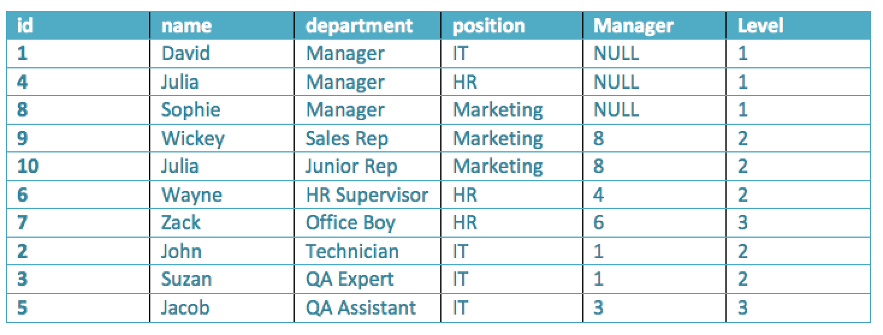

1. Write a Bank Account class in python to manage the account of the users. A user can deposit and withdraw money from his/her own account based on availability. Moreover, the account stores the following information **[10]**

Instance variables:

* 1. Name of the account
  2. Account number
  3. Current Balance

Methods:

1. Deposit
2. Withdraw
3. Show Balance

Note: The above information should be provided at the time of account creation.

1. Write a python function to calculate the sum of the following series: **[4]**

log(1) + log(2) + log(3) + …. + log(n) = ?

Note: The function takes the value of “n” as parameter and returns the sum.

Coding test guidelines: **[2]**

1. Open a new file in google colab. Name of the file: B1_CT_4_ID

2. Share the file with me ([tsr@uap-bd.edu](https://mail.google.com/mail/?view=cm&fs=1&to=tsr%40uap-bd.edu&authuser=0))

3. Make sure your webcam is on during the test.

4. Submit in the classroom properly. (from google drive)